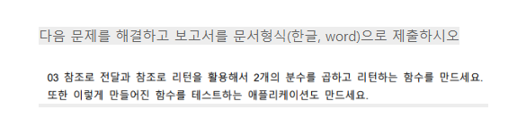

//course.h

#ifndef COURSE_H

#define COURSE_H

#include <iostream>

using namespace std;

class fraction

{

private:

    int molecular;

    int denominator;

public:

    fraction(int , int );

    ~fraction();

    int getNumer();

    int getDenom();

};

fraction& multipl(fraction&, fraction&);

#endif

//course.cpp

#include "course.h"

fraction::fraction(int fir, int sec) : molecular(fir), denominator(sec)

{

    cout << molecular << "/" << denominator << endl;

}

fraction::~fraction() {}

int fraction::getNumer()

{

    return molecular;

}

int fraction::getDenom()

{

    return denominator;

}

fraction& multipl(fraction& fract1, fraction& fract2)

{

    int check{};

    int mol = fract1.getNumer() * fract2.getNumer();

    int den = fract1.getDenom() * fract2.getDenom();

    if (mol > den)

        check = den;

    else

        check = mol;

    for (int i = 2; i <= check; ++i)

    {

        if (den % i == 0 && mol % i == 0)

        {

            den /= i;

            mol /= i;

            --i;

        }

    }

    fraction res{ mol,den };

    return res;

}

//main.cpp

#include "course.h"

int main()

{

    int mol1, den1, mol2, den2;

    cout << "곱할 두 분수를 입력하세요" << endl;

    cout << "분수1: ";

    cin >> mol1 >> den1;

    cout << "분수2: ";

    cin >> mol2 >> den2;

    fraction fract1(mol1, den1);

    fraction fract2(mol2, den2);

    cout << "두 분수의 곱: ";

    multipl(fract1, fract2);

}

